Computer Graphics Laboratory
SE
Assignment No: - A1

Revised On: 13/12/18

TITLE | Line drawing using DDA & Bresenham algorithm
PROBLEM STATEMENT /DEFINITION | Write C++ program to draw the following pattern using Line drawing algorithms. Use Bresenham’s line drawing algorithms for square and DDA line drawing algorithm for diamond.  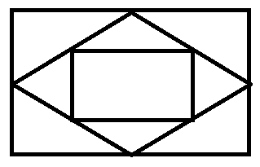
OBJECTIVE | - To understand concept of DDA Algorithm.  - To understand concept of Bresenham’s Algorithm.  - To understand concept & features of object oriented programming.  - To understand different manipulation facilities in QtCreator using C++.
S/W PACKAGES AND  HARDWARE APPARATUS USED | Operating Systems  1. Open source Linux or its derivative  2. Open Source C++ Programming tool like G++/GCC
REFERENCES | - J. Foley, V. Dam, S. Feiner, J. Hughes, “Computer Graphics Principles and Practice”, 2nd Edition,Pearson Education, 2003, ISBN 81 – 7808 – 038 – 9.  - D. Hearn, M. Baker, “Computer Graphics – C Version”, 2nd Edition, Pearson Education, 2002, ISBN,81 – 7808 – 794 – 4.  - D. Rogers, J. Adams, “Mathematical Elements for Computer Graphics”, 2nd Edition, Tata McGraw-Hill Publicati00on, 2002, ISBN 0 – 07 – 048677 – 8.
STEPS | Refer to student activity flow chart
INSTRUCTIONS FOR  WRITING JOURNAL | - Date  - Assignment no.  - Problem definition  - Learning objective  - Learning Outcome  - Concepts related Theory  - Related Mathematics  - Algorithm.  - Dry Run Example  - Test Cases  - Conclusion and applications
Assignment A1
- Aim
Write a C++ class for a Line drawing method using overloading DDA and Bresenham’s Algorithms, inheriting the pixel or point.

- Prerequisites
- Concept of drawing a pixel or point.
- Concept of drawing a line.
- Object oriented programming features.

- Learning Objectives
- To understand concept of DDA Algorithm.
- To understand concept of Bresenham’s Algorithms.
- To understand concept & features of object oriented programming.
- To understand different manipulation facilities in c++ .

- Learning Outcome
After successfully completing this assignment, you should be able to
- Draw a line using DDA Algorithm.
- Draw a line using Bresenham’s Algorithm.

- Concepts related Theory :-
- DDA Algorithm:-
Digital Differential Analyzer (DDA) is used for linear interpolation of variables over an interval between start and end point.
Digital differential analyzer(DDA)
Line Drawing Algorithm:

Begin.
If abs(x2-x1) ≥ abs (y2-y1) then
Length=abs(x2-x1)
Else
Length=abs(y2-y1)
End if.

Δx=(x2-x1)/length
Δy=(y2-y1)/length

Select the largest of Δx or Δy as one raster unit.
Round the values rather than truncate.

X=x1+0.5
Y=y1+0.5

Begin main loop
i=1
while(i≤length)
setpixel(Integer(x),integer(y))
x=x+Δx
y=y+Δy
i=i + 1
endwhile
finish.

- Bresenham’s Algorithm :-

Bresenham’s Algorithm:-
- Originally designed for digital plotters ,
Equally suited for use with CRT raster device

- Algorithm always increments by one unit in either
x or y depending on the slope of the line.

- The increment in other variable, either zero or
One is determined by examining the error term.
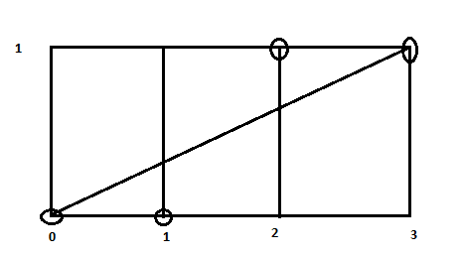

For,
e=e+m
ē/2Δx = ē/2Δx+Δy/Δx

ē=ē+2Δy

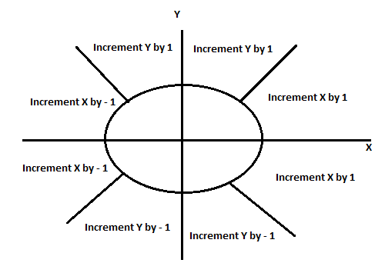

- Bresenham’s integer Algorithm for line :-

For the first octant the line end points are (x1,y1) and (x2,y2)
assumed not equal

All variables are assumed integer.

// initialize variables//

X=x1
Y=y1
Δx=x2-x1
Δy=y2-y1

//Initilalize ē to compensate for a non zero intercept//

ē=2*Δy-Δx
begin the main loop

for i=1 to Δx
setpixel(x,y)
while(ē>0)
y=y+1
ē=ē-2*Δx
endwhile
x=x+1
ē=ē+2*Δy
next i
finish.

Sr. No | Steps
1. | Enter the coordinates of line. | I= { x1,y1,x2,y2,choice}
2. | Enter a choice for drawing a line using DDA and Bresenham’s Algorithm. | Choice={DDA, Bresenham}
3. | Draw a line using DDA and Bresenham’s Algorithm. | O={Line}.  If choice=”DDA”  then  Draw a line using DDA Algorithm  Else  Draw a line using Bresenham’s Algorithm  end

- Review Questions
- What is DDA Algorithm?
- What is Bresenham’s Algorithm?
- Compare DDA Algorithm and Bresenham’s Algorithm?
- What are advantages of Bresenham’s Algorithm over DDA Algorithm?
- What are basic functions used for line drawing?

Test cases:

- Extra assignment list
  - Write a program to draw house using DDA line Algorithm
  - Write a program to draw different shapes like triangle, square, pentagon using Bresenham’s line Algorithm
  - Write a program to draw a Thick, Thin, Dotted lines using DDA line Algorithm?
  - Write a program to draw a Thick, Thin, Dotted lines using Bresenham’s Algorithm?

- Conclusion :
After successfully completing this assignment, student should be able to understand and implement line drawing using DDA algorithm and Bresenham’s Algorithm in C/ C++.

Computer Graphics Laboratory
SE
Assignment No: - A2

Asignment No. A2 Revised On: 13/12/18

TITLE | Draw Circle using DDA & Bresenham algorithm
PROBLEM STATEMENT /DEFINITION | Write C++ program to draw inscribed and Circumscribed circles in the triangle as shown in an example below. Use Bresenham’s Circle drawing algorithm for outer circle and DDA circle for inner circle. Use any Line drawing algorithm for drawing triangle  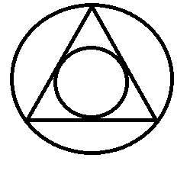
OBJECTIVE | - To understand concept & features of object oriented programming.  - To understand the concept of drawing circle using Bresenham’s & DDA circle drawing algorithm.
S/W PACKAGES AND  HARDWARE APPARATUS USED | Operating Systems  1. Open source Linux or its derivative  2. Open Source C++ Programming tool like G++/GCC
REFERENCES | - J. Foley, V. Dam, S. Feiner, J. Hughes, “Computer Graphics Principles and Practice”, 2nd Edition,Pearson Education, 2003, ISBN 81 – 7808 – 038 – 9.  - D. Hearn, M. Baker, “Computer Graphics – C Version”, 2nd Edition, Pearson Education, 2002, ISBN,81 – 7808 – 794 – 4.  - D. Rogers, J. Adams, “Mathematical Elements for Computer Graphics”, 2nd Edition, Tata McGraw-Hill Publicati00on, 2002, ISBN 0 – 07 – 048677 – 8.
STEPS | Refer to student activity flow chart
INSTRUCTIONS FOR  WRITING JOURNAL | 1.Date  2. Assignment no.  3.Problem definition  4.Learning objective  5.Learning Outcome  6.Concepts related Theory  7.Related Mathematics  8. Algorithm.  9.Dry Run Example  10.Test Cases  11.Conclusion and applications
Assignment A2
- Aim
Write a C++ class for a circle drawing inheriting line class.

- Prerequisites
- Concept of drawing a pixel or point.
- Concept of drawing a line.
- Object oriented programming features.

- Learning Objectives
- To understand concept of inheritance.
- To understand concept & features of object oriented programming.
- To understand different manipulation facilities in c++.

- Learning Outcome
After successfully completing this assignment, you should be able to
- Draw a circle by inheriting the members of line class.

- Related Mathematics

Let S be the system for drawing a circle by inheriting line class, such that
S = {s, e, DD , NDD I, O, F_{me} , F_{friend} | ᶲ};
Where,
s is a start state of the class S.
e is a end state of the class S.
DD = Deterministic data; here x interval dx, y interval dy along a line and slope of given line.
NDD = Non deterministic data; here tendency of line increment in horizon might be uncertain initially.

Input Analysis:-
I be the input to the system S. The system S takes x and y coordinates of center C of circle.
I_{i} = {C, r | C is the centre and r is the radius of circle.}
C = {(x, y) | x, y are x and y coordinates of centre C}
r = r is a finite positive integer.

Functions:-
F_{friend} is a friend class of class F_{me} having input parameter
F_{friend} = {C, r, f₁,f₂}
C is the Centre of circle.
R is radius of circle.
f₁ = acceptinput(); -function for accepting input from user.
f₂ = drawCircle(x, y, r); - function for drawing a line.

Output:-
O= {locus of points around centre as per the specified radius.}

- Concepts related Theory
- Bresenham’s Circle Generation Algorihtm:-

Only one octant of the circle need be generated. The other parts are obtained by successive reflection.

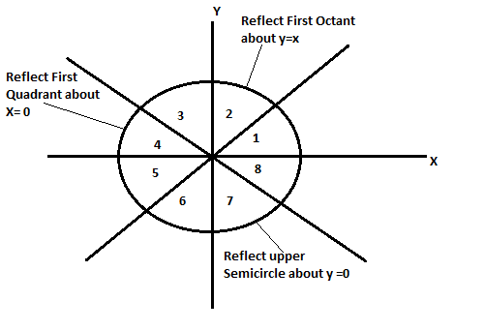

At x=0 and y=R for clockwise generation y is monotonically decreasing function of x.
At y=0, x=R for counterclockwise generation of the circle.
X is a monotonically decreasing function of y.

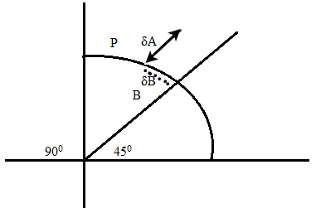

δ = | (x_{i} + 1)² + (y_{i})² – R² | - | (x_{i} + 1)² + (y_{i} - 1)² – R² |
Difference between the squares of the distance from the actual circle to M_{H} to M_{D}.
δ ≤ o Choose M_{H} at (x_{i} + 1, y_{i} )
δ ˃ o Choose M_{D} at (x_{i} + 1, y_{i} - 1)
Case 1:-
(x_{i} + 1)² + (y_{i})² – R² ≥ 0
(x_{i} + 1)² + (y_{i} - 1)² – R² ˂ 0
δ = (x_{i} + 1)² + (y_{i})² – R² + (x_{i} + 1)² + (y_{i} - 1)² – R²

Add and substitute -2y_{i} +1

δ = 2 [(x_{i} + 1)² + (y_{i} - 1)² – R² ] + 2y_{i} -1
Use Δi difference

δ = 2(Δi + y_{i} ) – 1.

Case 2:-

(x_{i} + 1)² + (y_{i})² – R² ˂ 0
(x_{i} + 1)² + (y_{i} - 1)² – R² ˂ 0

Case 3:-
Consider M_{D} and M_{V.}

δ' = | (x_{i} + 1)² + (y_{i} - 1)² – R² | - | (x_{i})² + (y_{i} - 1)² – R² |

δ’ ≤ o Choose M_{D} at (x_{i} + 1, y_{i} -1 )
δ’ ˃ o Choose M_{V} at (x_{i} , y_{i} - 1)
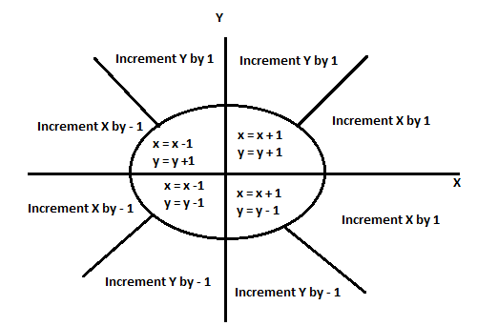
Conditions of General Bresenham’s Algorithm

Case 4:-

(x_{i} + 1)² + (y_{i} - 1)² – R² ˃ 0
(x_{i})² + (y_{i} - 1)² – R² ˃ 0
δ’ ˃ o Correct Choice M_{V}
Case 5:-

(x_{i} + 1)² + (y_{i} - 1)² – R² ˃ 0
(x_{i})² + (y_{i} - 1)² – R² = 0
So δ ˃ o Choose (x_{i} + 1, y_{i} -1 )

Δi = 0 (x_{i} + 1, y_{i} -1 ) M_{D}
Δi ˂ 0
δ ≤ 0 (x_{i} + 1, y_{i} ) M_{H}
δ ˃ 0 (x_{i} + 1, y_{i} -1 ) M_{D}

Δi ˃ 0
δ' ≤ 0 (x_{i} + 1, y_{i} -1 ) M_{D}
δ’ ˃ 0 (x_{i} , y_{i} -1 ) M_{v}

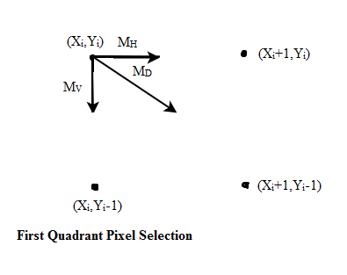

For any given point on the circle there are only three possible selection of the next pixel which best represents the circle, horizontally to the right, diagonally downward to the right and vertically downward.

Min (M_{H} , M_{D} ,M_{V})

M_{H} = |(x_{i} + 1)² + (y_{i})² – R² |
M_{D} = |(x_{i} + 1)² + (y_{i} - 1)² – R² |
M_{V} = |(x_{i} )² + (y_{i} - 1)² – R² |

If Δi ˂ 0
Then Point inside the circle.
If Δi ˃ 0
Then Point outside the circle.
Where
Δi = ( x_{i} + 1)² + (y_{i} - 1)² – R²

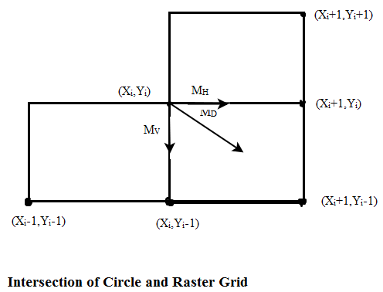

Bresenham’s Incremental Circle Drawing Algorithm:-
For the first quadrant, all variables assumed as integer.
//initialize variables//
X_{i} =0
Y_{i} = R
Δi = 2(1-R)
Limit = 0
While Y_{i} ≥ limit
Call setpixel(X_{i} ,Y_{i})
Determine if case 1 or 2, 4, 5 or 3
If Δi ˂ 0 then
δ = 2 Δi + 2 Y_{i} -1
Determine whether case 1 or 2
If δ ≤ 0 then
Call M_{H} (x_{i} , y_{i} , Δi)
Else
Call M_{D} (x_{i} , y_{i} , Δi)
End IF
ElseIf Δi ˃ 0 then
δ’ = 2 Δi - 2 X_{i} -1
Determine whether case 4 or 5
If δ’ ≤ 0 then
Call M_{D} (x_{i} , y_{i} , Δi)
Else
Call M_{V} (x_{i} , y_{i} , Δi)
End If
Else If Δi = 0 then
Call M_{D} (x_{i} , y_{i} , Δi)
End IF
End While
FINISH
Move Horizontally
Subroutine M_{H} (x_{i} , y_{i} , Δi)
x_{i} = x_{i} + 1
Δi = Δi +2 x_{i} +1
End Sub
Subroutine M_{D} (x_{i} , y_{i} , Δi)
x_{i} = x_{i} + 1
y_{i} = y_{i} - 1
Δi = Δi +2 x_{i} - 2 y_{i} + 2
End Sub

Move Vertically
Subroutine M_{V} (x_{i} , y_{i} , Δi)
y_{i} = y_{i} - 1
Δi = Δi - 2 y_{i} + 1
End Sub

- Review Questions
- Explain Bresenham’s circle drawing algorithm?
- Explain Δ,δ,δ’ in Bresenham’s circle drawing algorithm with relate mathematics.

- Extra assignment list
  - Design clock?

- Conclusion :
After successfully completing this assignment, student should be able to draw a circle by inheriting line class in C/ C++

Computer Graphics Laboratory
SE
Assignment No: - A3

Assignment A3 Revised On: 13/12/2018
TITLE | To plot graphically Mandelbrot and Julia set.
PROBLEM STATEMENT /DEFINITION | A Mandelbrot Set is a set of complex number z that does not diverge under the transformation with .Where, both X and z represents the complex numbers. Write C++/Java program to  a) Plot the Mandelbrot set for the threshold |x|= 2.  b) Plot Julia set choosing z ≠ 0. Use 254 colors for plotting in both cases.
OBJECTIVE | - To understand mathematical concept behind Madelbrot & Julia set.  - To plot elements of Madelbrot & Julia set graphically
S/W PACKAGES AND  HARDWARE APPARATUS USED | 1. Open source Linux or its derivative  2. Open Source C++ Programming tool like G++/GCC
REFERENCES | - J. Foley, V. Dam, S. Feiner, J. Hughes, “Computer Graphics Principles and Practice”, 2nd Edition,Pearson Education, 2003, ISBN 81 – 7808 – 038 – 9.  - D. Hearn, M. Baker, “Computer Graphics – C Version”, 2nd Edition, Pearson Education, 2002, ISBN,81 – 7808 – 794 – 4.  - D. Rogers, J. Adams, “Mathematical Elements for Computer Graphics”, 2nd Edition, Tata McGraw-Hill Publicati00on, 2002, ISBN 0 – 07 – 048677 – 8.
INSTRUCTIONS FOR  WRITING JOURNAL | 1.Date  2. Assignment no.  3.Problem definition  4.Learning objective  5.Learning Outcome  6.Concepts related Theory  7.Related Mathematics  8. Algorithm.  9.Dry Run Example  10.Test Cases  11.Conclusion and applications

Concept related Theory:
Mandelbrot set: The Mandelbrot set is the set of complex numbers C, for which the function f _{c} (z)=z² + C does not diverge when iterated from z=0,
i.e., for which the sequence f _{c} (0), f _{c} (f _{c} (0)), etc., remains bounded in absolute value.
Its definition and name are due to Adrien Douady, in tribute to the mathematician Benoit Mandelbrot. The set is connected to a Julia set, and related Julia sets produce similarly complex fractal shapes

Formal definition:
The Mandelbrot set is the set of values of c in the complex plane for which the orbit of 0 under iteration of the quadratic map
Zn = Z²_{n} +C remains bounded.
That is, a complex number c is part of the Mandelbrot set if, when starting with z₀ = 0 and applying the iteration repeatedly, the absolute value of z_{n} remains bounded however large n gets.

Julia Set: In the context of complex dynamics, a topic of mathematics, the Julia set and the Fatou set are two complementary sets (Julia 'laces' and Fatou 'dusts') defined from a function. Informally, the Fatou set of the function consists of values with the property that all nearby values behave similarly under repeated iteration of the function, and the Julia set consists of values such that an arbitrarily small perturbation can cause drastic changes in the sequence of iterated function values. Thus the behavior of the function on the Fatou set is 'regular', while on the Julia set its behavior is 'chaotic'.

Example:
For f (z)=z² , the Julia set is the unit circle and on this the iteration is given by doubling of angles (an operation that is chaotic on the points whose argument is not a rational fraction of 2П).
There are two Fatou domains: the interior and the exterior of the circle, with iteration towards 0 and ∞, respectively.
Output:


Julia set for f_{c}, c=(φ−2)+(φ−1)i =-0.4+0.6i

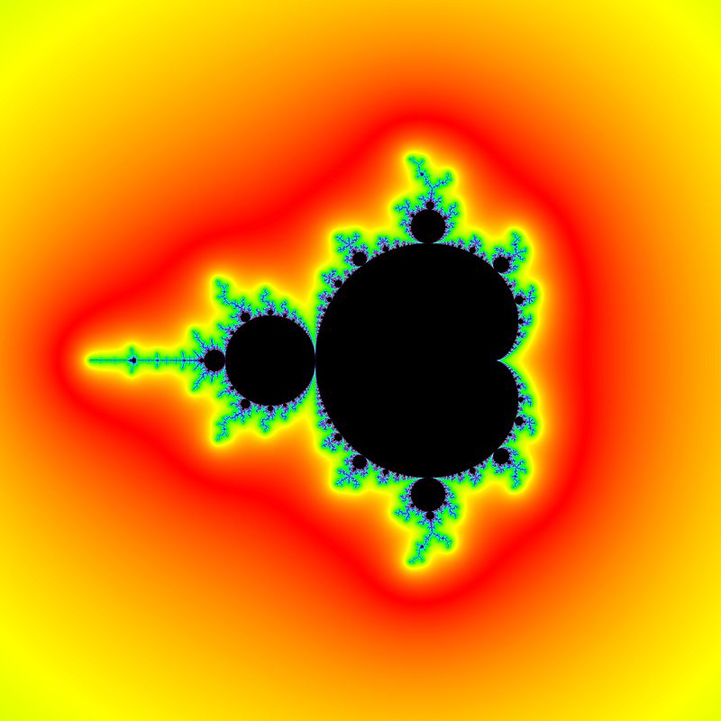
Fig: Exterior distance estimate may be used to color whole complement of Mandelbrot set

- Conclusion :
After successfully completing this assignment, student should be able to draw graphically Mandelbrot and Julia set.

Computer Graphics Laboratory
SE

Assignment No: - A4

Assignment A4 Revised On: 13/12/2018
TITLE | To Implement 2D transformations.
PROBLEM STATEMENT /DEFINITION | Write C++/Java program to draw 2-D object and perform following basic transformations,  a) Scaling  b) Translation  c) Rotation  Use operator overloading.
OBJECTIVE | - To understand mathematical concepts behind implementation of 2D transformations  - To Implement 2D transformations using matrix multiplication in C++/Java
S/W PACKAGES AND  HARDWARE APPARATUS USED | 1. Open source Linux or its derivative  2. Open Source C++ Programming tool like G++/GCC
REFERENCES | - J. Foley, V. Dam, S. Feiner, J. Hughes, “Computer Graphics Principles and Practice”, 2nd Edition,Pearson Education, 2003, ISBN 81 – 7808 – 038 – 9.  - D. Hearn, M. Baker, “Computer Graphics – C Version”, 2nd Edition, Pearson Education, 2002, ISBN,81 – 7808 – 794 – 4.  - D. Rogers, J. Adams, “Mathematical Elements for Computer Graphics”, 2nd Edition, Tata McGraw-Hill Publicati00on, 2002, ISBN 0 – 07 – 048677 – 8.
INSTRUCTIONS FOR  WRITING JOURNAL | 1.Date  2. Assignment no.  3.Problem definition  4.Learning objective  5.Learning Outcome  6.Concepts related Theory  7.Related Mathematics  8. Algorithm.  9.Dry Run Example  10.Test Cases  11.Conclusion and applications

Assignment A4
- Aim
Write C++/Java program to draw 2-D object and perform following basic transformations.

Prerequisites
- Concept of drawing a line.
- Object oriented programming features.

- Learning Objectives
- To understand concept & features of object oriented programming.
- To understand the basic graphic functions in C/C++.

- Learning Outcome
After successfully completing this assignment, you should be able to draw different transformations like scaling, translation and rotation.

- Concepts related Theory :-
- A scaling transformation:
A scaling transformation alters size of an object. In the scaling process, we either compress or expand the dimension of the object.
Scaling operation can be achieved by multiplying each vertex coordinate (x, y) of the polygon by scaling factor sx and sy to produce the transformed coordinates as (x’, y’).

So, x’ = x * sx and
y’ = y * sy.
The scaling factor sx, sy scales the object in X and Y direction respectively. So, the above equation can be represented in matrix form:

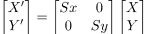
Or P’ = S . P
Scaling process:
If the scaling factor S is less than 1, then we reduce the size of the object. If the scaling factor S is greater than 1, then we increase size of the object.

Algorithm:
1. Make a 2x2 scaling matrix S as:
Sx 0
0 Sy
2. For each point of the polygon.
(i) Make a 2x1 matrix P, where P[0][0] equals to x coordinate of the point and P[1][0]
equals to y coordinate of the point.
(ii) Multiply scaling matrix S with point matrix P to get the new coordinate.
3. Draw the polygon using new coordinates.

Translation:
A translation moves an object to a different position on the screen. You can translate a point in 2D by adding translation coordinate (tx, ty) to the original coordinate (X, Y) to get the new coordinate (X’, Y’).

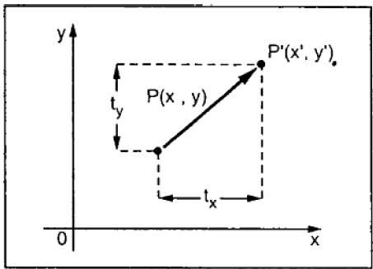
X’ = X + tx

Y’ = Y + ty
The pair (tx, ty) is called the translation vector or shift vector. The above equations can also be represented using the column vectors.

P=[X][Y] p' = [X′][Y′]T = [tx][ty]

We can write it as −

P’ = P + T

Rotation:
In rotation, we rotate the object at particular angle θ (theta) from its origin. From the following figure, we can see that the point P(X, Y) is located at angle φ from the horizontal X coordinate with distance r from the origin.

Let us suppose you want to rotate it at the angle θ. After rotating it to a new location, you will get a new point P’ (X’, Y’).

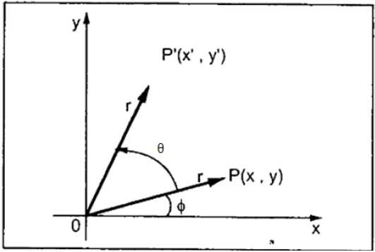
Using standard trigonometric the original coordinate of point P(X, Y) can be represented as −

X=rcosϕ......(1)
Y=rsinϕ......(2)
Same way we can represent the point P’ (X’, Y’) as −

x′=rcos(ϕ+θ)=rcosϕcosθ−rsinϕsinθ.......(3)
y′=rsin(ϕ+θ)=rcosϕsinθ+rsinϕcosθ.......(4)
Substituting equation (1) & (2) in (3) & (4) respectively, we will get

x′=xcosθ−ysinθ
y′=xsinθ+ycosθ
Representing the above equation in matrix form,
[X′Y′]=[XY][cosθ sinθ
-sinθ cosθ] OR

P’ = P . R
Where R is the rotation matrix

R=[cosθ sinθ
-sinθ cosθ]

Conclusion:
After successfully completing this assignment, student should be able to perform basic transformations like translation, scaling and rotation in C/ C++.

Computer Graphics Laboratory
SE
Assignment No: - A5

Assignment A5 Revised On: 13/12/2018

TITLE | To Draw polygons using mouse click event handling.
PROBLEM STATEMENT /DEFINITION | Write C++ program to draw the polygons by using the mouse. Choose colors by clicking on the designed color pane. Use window port to draw. Use DDA algorithm for line drawing.
OBJECTIVE | - To understand concept of polygon drawing  - To understand the basic graphic functions in C++ for mouse click event handling.
S/W PACKAGES AND  HARDWARE APPARATUS USED | Operating Systems  1. Open source Linux or its derivative  2. Open Source C++ Programming tool like G++/GCC
REFERENCES | - J. Foley, V. Dam, S. Feiner, J. Hughes, “Computer Graphics Principles and Practice”, 2nd Edition,Pearson Education, 2003, ISBN 81 – 7808 – 038 – 9.  - D. Hearn, M. Baker, “Computer Graphics – C Version”, 2nd Edition, Pearson Education, 2002, ISBN,81 – 7808 – 794 – 4.  - D. Rogers, J. Adams, “Mathematical Elements for Computer Graphics”, 2nd Edition, Tata McGraw-Hill Publicati00on, 2002, ISBN 0 – 07 – 048677 – 8.
INSTRUCTIONS FOR  WRITING JOURNAL | 1.Date  2. Assignment no.  3.Problem definition  4.Learning objective  5.Learning Outcome  6.Concepts related Theory  7.Related Mathematics  8. Algorithm.  9.Dry Run Example  10.Test Cases  11.Conclusion and applications

Assignment A5
- Aim
Write a C/C++ program to draw a polygon with programmable edges.

Prerequisites
- Concept of drawing a line.
- Object oriented programming features.

- Learning Objectives
- To understand concept & features of object oriented programming.
- To understand the basic graphic functions in C/C++.

- Learning Outcome
After successfully completing this assignment, you should be able to draw a convex polygon with programmable edges.

- Related Mathematics
Let S be the system for drawing a Convex polygon with programmable edges, such that
S = {s, e, I, O, DD, NDD, F_{me} , F_{friend} | ᶲ};
Where,
s is a start state of the class S.
x and y coordinates of vertices of edge are initialized to zero.
e is a end state of the class S.
DD = Deterministic data; here x interval dx, y interval dy along a line and slope of given line.
NDD = Non deterministic data; here tendency of line increment in horizon might be uncertain initially.
Input Analysis:-
I be the input to the system S. The system S takes x and y coordinates of vertices V of polygon.
I_{i} = { V₁, V₂, …V_{n}.| Vi are vertices of polygon.}
V_{i} = {(x_{i,} y_{i}) | x_{i,} y_{i} are x and y coordinates of vertices of polygon.}
Functions:-
F_{friend} is a friend class of class F_{me} having input parameter
F_{friend} = { V_{i} , f₁, f₂ }
f₁ = acceptinput(); -function for accepting input from user.
f₂ = drawpolygon(V₁, V₂, …V_{n}.); - function for drawing a line using DDA algorithm.

Output:-
O= {Polygon displayed on the screen.}

- Concepts related Theory :-
- Convex polygon:-
A convex polygon is a simple polygon whose interior is a convex set. The following properties of a simple polygon are both equivalent to convexity:
• Every internal angle is less than or equal to 180 degrees.
• Every line segment between two vertices remains inside or on the boundary of the polygon.
A simple polygon is strictly convex if every internal angle is strictly less than 180 degrees. Equivalently, a polygon is strictly convex if every line segment between two nonadjacent vertices of the polygon is strictly interior to the polygon except at its endpoints. A convex polygon is defined as a polygon with all its interior angles less than 180°. This means that all the vertices of the polygon will point outwards, away from the interior of the shape. Think of it as a 'bulging' polygon. Note that a triangle (3-gon) is always convex.

Concave or non-convex polygons:-

A simple polygon that is not convex is called concave, non-convex or reentrant. A concave polygon will always have an interior angle with a measure that is greater than 180 degrees. It is always possible to partition a concave polygon into a set of convex polygons.
A concave polygon is defined as a polygon with one or more interior angles greater than 180°. It looks sort of like a vertex has been 'pushed in' towards the inside of the polygon. Note that a triangle (3-gon) can never be concave.

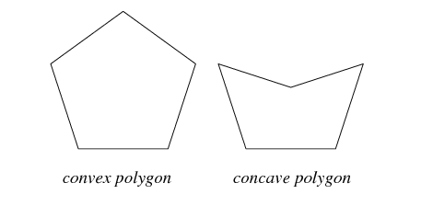

- Review Questions
- What is polygon?
- Explain convex and concave polygon?

- Extra assignment list
Write a C/C++ program to draw a house with polygon drawing function?

- Conclusion :
After successfully completing this assignment, student should be able to understand and draw a convex polygon with programmable edges C/ C++.

Computer Graphics Laboratory
SE
Assignment No: - B1

Assignment B1 Revised On: 18/12/2017

TITLE | To draw line with different patterns.
PROBLEM STATEMENT /DEFINITION | Write C++/Java program for line drawing using DDA or Bresenham’s algorithm with patterns such as solid, dotted, dashed, dash dot and thick.
OBJECTIVE | - To understand concept of different line styales, e.g. thick,thin dotted etc.  - To Implement DDA/Bresenham for drawing lines.
S/W PACKAGES AND  HARDWARE APPARATUS USED | Operating Systems  1. Open source Linux or its derivative  2. Open Source C++ Programming tool like G++/GCC
REFERENCES | - J. Foley, V. Dam, S. Feiner, J. Hughes, “Computer Graphics Principles and Practice”, 2nd Edition,Pearson Education, 2003, ISBN 81 – 7808 – 038 – 9.  - D. Hearn, M. Baker, “Computer Graphics – C Version”, 2nd Edition, Pearson Education, 2002, ISBN,81 – 7808 – 794 – 4.  - D. Rogers, J. Adams, “Mathematical Elements for Computer Graphics”, 2nd Edition, Tata McGraw-Hill Publicati00on, 2002, ISBN 0 – 07 – 048677 – 8.
INSTRUCTIONS FOR  WRITING JOURNAL | 1.Date  2. Assignment no.  3.Problem definition  4.Learning objective  5.Learning Outcome  6.Concepts related Theory  7.Related Mathematics  8. Algorithm.  9.Dry Run Example  10.Test Cases  11.Conclusion and applications

Aim:
Write C++/Java program for line drawing using DDA or Bresenham’s algorithm with patterns such as solid, dotted, dashed, dash dot and thick.

Prerequisites:
Line Drawing Algorithm
Different types of line.
- Learning Objectives
To understand the concepts of patterns of line.
To improve the coding skill of students
To learn the concept of anti-aliasing.
- Learning Outcome
After completion of this assignment student should able to draw different line patterns.
Related Mathematics:
Let S be the system for drawing a line using DDA algorithm and Bresenham’s Algorithm, such that
S = {s, e, I, O, DD, NDD, F_{me} , F_{friend} | ᶲ};
Where,
s is a start state of the class S.
x and y coordinates of start point and end point of line are initialized to zero.
e is a end state of the class S.
DD = Deterministic data; here x interval dx, y interval dy along a line and slope of given line.
NDD = Non deterministic data; here tendency of line increment in horizon might be uncertain initially.
Input Analysis:-
I be the input to the system S. The system S takes x and y coordinates of point p₁, p₂.
I_{i} = {(p₁, p₂) | p₁, p₂ are end points of line segment}
P_{i} = {(x_{i,} y_{i}) | x_{i,} y_{i} are x and y coordinates of point p_{i}}
Functions:-
F_{friend} is a friend class of class F_{me} having input parameter
F_{friend} = { p₁, p_{2,} f₁, f₂ ,f₃}
f₁ = acceptinput(); -function for accepting input from user.
f₂ = ddaLine(p₁, p₂); - function for drawing a line using DDA algorithm.
f₃ = bresenhamLine(p₁, p₂); - function for drawing a line using Bresenham’s algorithm.
Output:-
O= {p₁, p2, ….pn | where P_{i} Ɛ L ˄ L satisfies y = mx + C }

- Concepts related Theory :-
Draws a dashed and dotted line using DDA Algorithm. Takes the line co-ordinates from the user to plot the desired line. The program starts with one given end point and then calculates each successive pixel that lies on the line using DDA Algorithm. To make the line dashed and dotted,the program plots some pixels in order and then skips some pixels to produce the dotted effect. Alternate pixels are plotted to produce the dotted line effect. Applying these two simultaneously we the dashed-dotted line effect.
- Review Questions
What is aliasing?
What is anti-aliasing?
Why aliasing occur in Raster scan display?

Conclusion:
After completion of this assignment student should able to draw different line patterns.

Computer Graphics Laboratory
SE

Assignment No: - B2

Assignment B2 Revised On: 18/12/2017

TITLE | To Implement seed fill.
PROBLEM STATEMENT /DEFINITION | Write C++/Java program to draw a convex polygon and fill it with desired color using Seed fill algorithm. Use mouse interfacing to draw polygon.
OBJECTIVE | - To understand concept of seed fill.  - To fill polygon using seed fill algorithm.
S/W PACKAGES AND  HARDWARE APPARATUS USED | Operating Systems  1. Open source Linux or its derivative  2. Open Source C++ Programming tool like G++/GCC
REFERENCES | - J. Foley, V. Dam, S. Feiner, J. Hughes, “Computer Graphics Principles and Practice”, 2nd Edition,Pearson Education, 2003, ISBN 81 – 7808 – 038 – 9.  - D. Hearn, M. Baker, “Computer Graphics – C Version”, 2nd Edition, Pearson Education, 2002, ISBN,81 – 7808 – 794 – 4.  - D. Rogers, J. Adams, “Mathematical Elements for Computer Graphics”, 2nd Edition, Tata McGraw-Hill Publicati00on, 2002, ISBN 0 – 07 – 048677 – 8.
INSTRUCTIONS FOR  WRITING JOURNAL | 1.Date  2. Assignment no.  3.Problem definition  4.Learning objective  5.Learning Outcome  6.Concepts related Theory  7.Related Mathematics  8. Algorithm.  9.Dry Run Example  10.Test Cases  11.Conclusion and applications

Concept related theory:
- Polygon filling: process of coloring the area of a polygon
- Decide whether the point is inside or outside of the polygon.
- Inside → change to filled color
- Outside→ remain same as of background color
- Area/Region: collection of pixels



Seed fill algorithm:
- Boundary fill & flood fill algorithm together is called as seed-fill algorithm
- Principle: “start at a sample pixel called as a seed pixel from the area, fill the color value & the boundary color value”.
- Areas can be defined at 2 levels
  - 1. pixel level
  - 2. geometric level
Simple seed fill algorithm using stack
- Push the seed pixel to stack.
- While stack is not empty
Pop a pixel from stack
Set pixel to req value
For each of 4-connected pixels adjacent to the current pixel
check if it is boundary pixel, or if it has already been set to the required value. In either case, neglect it.
Otherwise, push it onto the stack.
Algorithm for 4- connected component
- Read SeedPixel(x,y), fill, boundary
- Pushpixel(x,y)
- While (stack<>empty)
- Poppixel(x,y)
- Setpixel(x,y,fill)
- If(getpixel(x+1,y))<>fill && getpixel(x+1,y)<>boundary
- Pushpixel(x+1,y)
- If(getpixel(x-1,y))<>fill && getpixel(x-1,y)<>boundary
- Pushpixel(x-1,y)
- If(getpixel(x,y+1))<>fill && getpixel(x,y+1)<>boundary
- Pushpixel(x,y+1)
- If(getpixel(x,y-1))<>fill && getpixel(x,y-1)<>boundary
- Pushpixel(x,y-1)
- End while

Output:

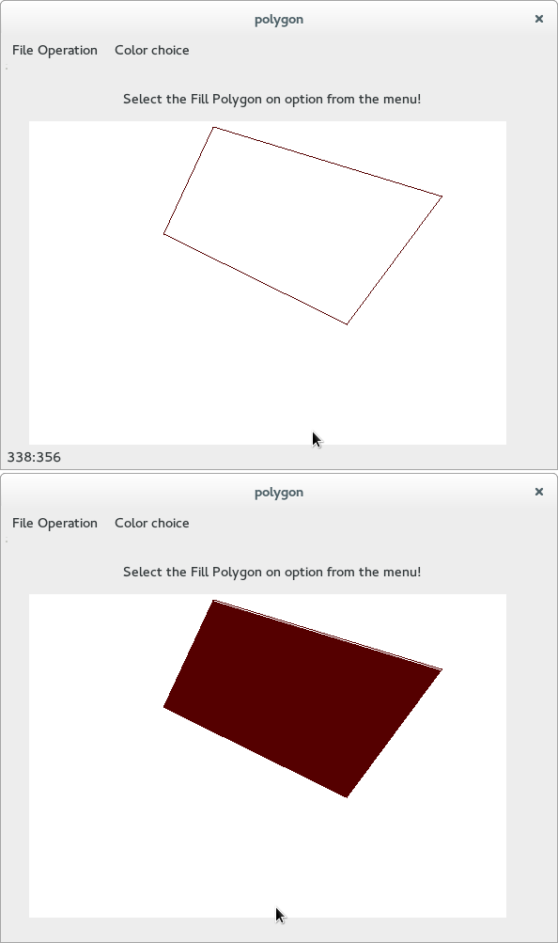

Computer Graphics Laboratory
SE

Assignment No: - B3

Assignment B3 Revised On: 18/12/2017

TITLE | To clip line using algorithm
PROBLEM STATEMENT /DEFINITION | Write C++/Java program to implement Cohen-Sutherland line clipping algorithm for given  window. Draw line using mouse interfacing to draw polygon
OBJECTIVE | - To understand concept of different clipping algorithm  - To Implement Cohen-sutherland algorithm  - to draw lines by mouse interfacing
S/W PACKAGES AND  HARDWARE APPARATUS USED | Operating Systems  1. Open source Linux or its derivative  2. Open Source C++ Programming tool like G++/GCC
REFERENCES | - J. Foley, V. Dam, S. Feiner, J. Hughes, “Computer Graphics Principles and Practice”, 2nd Edition,Pearson Education, 2003, ISBN 81 – 7808 – 038 – 9.  - D. Hearn, M. Baker, “Computer Graphics – C Version”, 2nd Edition, Pearson Education, 2002, ISBN,81 – 7808 – 794 – 4.  - D. Rogers, J. Adams, “Mathematical Elements for Computer Graphics”, 2nd Edition, Tata McGraw-Hill Publicati00on, 2002, ISBN 0 – 07 – 048677 – 8.
INSTRUCTIONS FOR  WRITING JOURNAL | 1.Date  2. Assignment no.  3.Problem definition  4.Learning objective  5.Learning Outcome  6.Concepts related Theory  7.Related Mathematics  8. Algorithm.  9.Dry Run Example  10.Test Cases  11.Conclusion and applications

Aim:
Write C++/Java program to implement Cohen-Sutherland line clipping algorithm for given

window. Draw line using mouse interfacing to draw polygon

Prerequisites:
Line Drawing Algorithm.
Mouse interfacing.
Clipping related algorithm
- Learning Objectives
To understand the concepts of mouse interfacing
To improve the coding skill of students
To learn the concept of Clipping
- Learning Outcome
After completion of this assignment student should able to clip line as per the clipping window.
Related Mathematics:
Let S be the system for clipping line
S = {s, e, I, O, DD, NDD, F_{me} , F_{friend} | ᶲ};
Where,
s is a start state of the class S.
x and y coordinates of start point and end point of line are initialized to zero.
e is a end state of the class S.
DD = Deterministic data; here x interval dx, y interval dy along a line and slope of given line.
NDD = Non deterministic data; here tendency of line increment in horizon might be uncertain initially.
Input Analysis:-
I be the input to the system S. The system S takes x and y coordinates of point p₁,p₂

I_{i} = {(p₁, p₂) | p₁, p₂ are end points of line segment}
P_{i} = {(x_{i,} y_{i}) | x_{i,} y_{i} are x and y coordinates of point p_{i}}
Functions:-
mouse interfacing for input to the algorithm.
clipping function with respect to desire window.
Output:
Success: Successful clipping of line.
Failure: after clipping lines which are outside clipping boundary are also visible.
- Concepts related Theory :-
The algorithm includes, excludes or partially includes the line based on whether:
- Both endpoints are in the viewport region (bitwise OR of endpoints = 00): trivia accept.
- Both endpoints share at least one non-visible region, which implies that the line does not cross the visible region. (bitwise AND of endpoints ≠ 0): trivial reject.
- Both endpoints are in different regions: in case of this nontrivial situation the algorithm finds one of the two points that is outside the viewport region (there will be at least one point outside). The intersection of the outpoint and extended viewport border is then calculated (i.e. with the parametric equation for the line), and this new point replaces the outpoint. The algorithm repeats until a trivial accept or reject occurs.

- Review Questions
What is clipping?
What are the different algorithm related to clipping?
Explain Cohen-Sutherland algorithm in detail?
Why bit code play important role in Cohen-Sutherland algorithm?

Conclusion:
After completion of this assignment student should able clip line with respect to desire window.

Computer Graphics Laboratory
SE

Assignment No: - B4

Assignment No. B4 Revised On: 17/12/2018
TITLE | Reflection of 2-D object about X axis, Y axis and about X=Y axis.
PROBLEM STATEMENT /DEFINITION | Write C++/Java program to implement reflection of 2-D object about X axis, Y axis and about X=Y axis. Also rotate object about arbitrary point given by user.
OBJECTIVE | - To understand mathematical concepts behind implementation of 2D transformations  - To Implement 2D reflection using matrix multiplication in C++/Java
S/W PACKAGES AND  HARDWARE APPARATUS USED | 1. Open source Linux or its derivative  2. Open Source C++ Programming tool like G++/GCC
REFERENCES | - J. Foley, V. Dam, S. Feiner, J. Hughes, “Computer Graphics Principles and Practice”, 2nd Edition, Pearson Education, 2003, ISBN 81 – 7808 – 038 – 9.  - D. Hearn, M. Baker, “Computer Graphics – C Version”, 2nd Edition, Pearson Education, 2002, ISBN, 81 – 7808 – 794 – 4.  - D. Rogers, J. Adams, “Mathematical Elements for Computer Graphics”, 2nd Edition, Tata McGraw-Hill Publication, 2002, ISBN 0 – 07 – 048677 – 8.
INSTRUCTIONS FOR  WRITING JOURNAL | 1.Date  2. Assignment no.  3.Problem definition  4.Learning objective  5.Learning Outcome  6.Concepts related Theory  7.Related Mathematics  8. Algorithm.  9.Dry Run Example  10.Test Cases  11.Conclusion and applications

- Aim
Write C++/Java program to implement reflection of 2-D object about X axis, Y axis and about X=Y axis. Also rotate object about arbitrary point given by user.

- Prerequisites
- Concept of linear algebra with vectors, matrices, and transforms.
- Object oriented programming features operator overloading in classes.

- Learning Objectives
- It introduces the basics of linear algebra with vectors, matrices, and transforms.
- It shows you how linear algebra relates to simple computer graphics.
- It gives you practice with operator overloading in classes.

- Learning Outcome
After successfully completing this assignment, you should be able to
- Reflection of 2-D object about X axis, Y axis and about X=Y axis.

- Related Mathematics
Let S be the system for drawing a 2-D object (for e.g. Triangle)
S = {s, e, I, O, DD, NDD, F, θ (theta)};
Where,
s is a start state of the class S.
x and y coordinates of start point and end point of line are initialized to zero.
e is a end state of the class S.
DD = Deterministic data.
NDD = Non deterministic data; here tendency of line increment in horizon might be uncertain initially.
Input Analysis:-
I be the input to the system S. The system S takes x and y coordinates of point p₁, p₂.
I_{i} = {(p₁, p₂) | p₁, p₂ are end points of line segment}
P_{i} = {(x_{i,} y_{i}) | x_{i,} y_{i} are x and y coordinates of point p_{i}}
Functions:-
F is a class having input parameter
F = { f₁, f_{2,} f₃, f₄}
f₁ = drawObject (); -function for accepting input from user to draw object.
f₂ = reflectXaxis(); - function for reflecting 2D object about X axis.
f₃ = reflectYaxis(); - function for reflecting 2D object about X axis.
f₄ = reflectXYaxis(); - function for reflecting 2D object about X=Y axis.

Output:-
O= {Display 2-D object according to reflection choice on screen}

- Concepts related Theory :-

2D transformations:

Reflection is nothing but producing mirror image of an object. Reflection can be done just by rotating the object about given axis of reflection with an angle of 180 degrees.

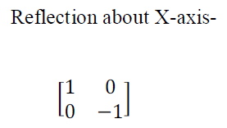
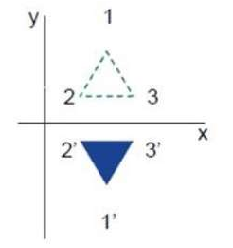

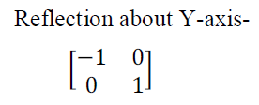
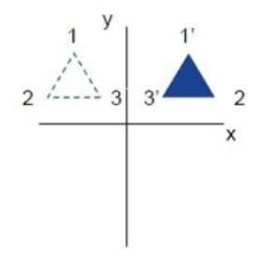

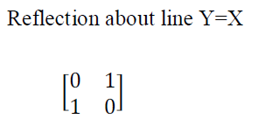

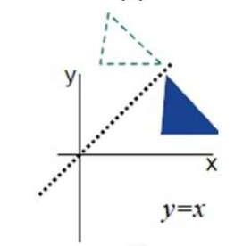

- Conclusion :
After successfully completing this assignment, student should be able to perform basic 2D reflection about X axis, Y axis and about X=Y axis.

Computer Graphics Laboratory
SE

Assignment No: - B5

Assignment No. B5 Revised On: 07/03/2018
TITLE | Hilbert curve using concept of fractals.
PROBLEM STATEMENT /DEFINITION | Write C++/Java program to generate Hilbert curve using concept of fractals.
OBJECTIVE | - To understand mathematical concepts Hilbert curve using concept of fractals.
S/W PACKAGES AND  HARDWARE APPARATUS USED | 1. Open source Linux or its derivative  2. Open Source C++ Programming tool like G++/GCC
REFERENCES | - J. Foley, V. Dam, S. Feiner, J. Hughes, “Computer Graphics Principles and Practice”, 2nd Edition, Pearson Education, 2003, ISBN 81 – 7808 – 038 – 9.  - D. Hearn, M. Baker, “Computer Graphics – C Version”, 2nd Edition, Pearson Education, 2002, ISBN, 81 – 7808 – 794 – 4.  - D. Rogers, J. Adams, “Mathematical Elements for Computer Graphics”, 2nd Edition, Tata McGraw-Hill Publication, 2002, ISBN 0 – 07 – 048677 – 8.
INSTRUCTIONS FOR  WRITING JOURNAL | 1.Date  2. Assignment no.  3.Problem definition  4.Learning objective  5.Learning Outcome  6.Concepts related Theory  7.Related Mathematics  8. Algorithm.  9.Dry Run Example  10.Test Cases  11.Conclusion and applications

- Aim
Write C++/Java program to generate Hilbert curve using concept of fractals.

- Prerequisites
- Concept of linear algebra with vectors, matrices, and transforms.
- Object oriented programming features operator overloading in classes.

- Learning Objectives
- It introduces the basics of linear algebra with vectors, matrices, and transforms.
- It shows you how linear algebra relates to simple computer graphics.

- Learning Outcome
After successfully completing this assignment, you should be able to
- Generate Hilbert curve using concept of fractals.

- Related Mathematics
Let S be the system for drawing a 2-D object
S = {s, e, I, O, DD, NDD, F};
Where,
s is a start state of the class S.
x and y coordinates of start point and end point of line are initialized to zero.
e is a end state of the class S.
DD = Deterministic data.
NDD = Non deterministic data; here tendency of line increment in horizon might be uncertain initially.
Input Analysis:-
I be the input to the system S.

Functions:-
F is a class having input parameter
F = { f₁}
f₁ = hilbert(); -function to generate Hilbert curve using concept of fractals..

Output:-
O= {Hilbert curve}

- Concepts related Theory :-

Hilbert curve:
Space filling curve.
Drawn by connecting centers of 4 sub‐squares, make up larger square.
Iteration 0: 3 segments connect 4 centers in upside‐down U.

Reflection is nothing but producing mirror image of an object. Reflection can be done just by rotating the object about given axis of reflection with an angle of 180 degrees.

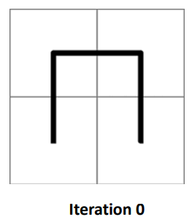

Hilbert Curve: Iteration 1
Each of 4 squares divided into 4 more squares.
U shape shrunk to half its original size, copied into 4 sectors.
In top left, simply copied, top right: it's flipped vertically.
In the bottom left, rotated 90 degrees clockwise.
Bottom right, rotated 90 degrees counter‐clockwise.
4 pieces connected with 3 segments, each of which is same size as the shrunken pieces of the U shape (in red).

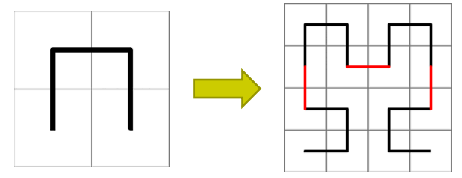

Hilbert Curve: Iteration 2
Each of the 16 squares from iteration 1 divided into 4 squares.
Shape from iteration 1 shrunk and copied.
3 connecting segments (shown in red) are added to complete the curve.

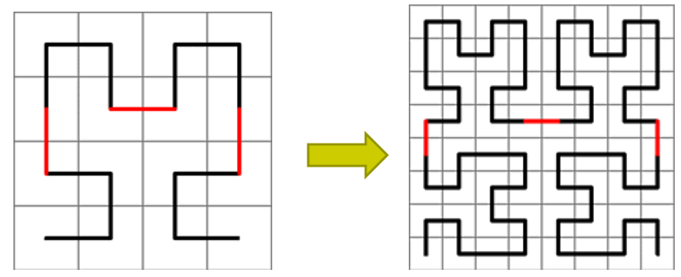

- Conclusion :
After successfully completing this assignment, student should be able to generate Hilbert curve using concept of fractals.

Programming Laboratory
SE
Assignment No: - C1

Assignment C1 Revised On: 18/12/17
TITLE | To implement 3D transformations.
PROBLEM STATEMENT /DEFINITION | Write C++/Java program to draw 3-D cube and perform following transformations on it using OpenGL. A) Scaling b) Translation c) Rotation about one axis.
OBJECTIVE | - To understand concept & features of OpenGL.  - To understand the basic graphic functions in OpenGL  - To understand & Implement 3D transformations using OpenGL library functions.
S/W PACKAGES AND  HARDWARE APPARATUS USED | Operating Systems  1. Open source Linux or its derivative  2. Open Source C++ Programming tool like G++/GCC
REFERENCES | - J. Foley, V. Dam, S. Feiner, J. Hughes, “Computer Graphics Principles and Practice”, 2nd Edition,Pearson Education, 2003, ISBN 81 – 7808 – 038 – 9.  - D. Hearn, M. Baker, “Computer Graphics – C Version”, 2nd Edition, Pearson Education, 2002, ISBN,81 – 7808 – 794 – 4.  - D. Rogers, J. Adams, “Mathematical Elements for Computer Graphics”, 2nd Edition, Tata McGraw-Hill Publication, 2002, ISBN 0 – 07 – 048677 – 8.  - http://graphics.wikia.com/wiki/OpenGL
INSTRUCTIONS FOR  WRITING JOURNAL | 1.Date  2. Assignment no.  3.Problem definition  4.Learning objective  5.Learning Outcome  6.Concepts related Theory  7.Related Mathematics  8. Algorithm.  9.Dry Run Example  10.Test Cases  11.Conclusion and applications

Assignment C1

- Aim
Use OpenGL graphics library functions to implement 3D transformations.
Prerequisites
- Concept of 3D transformations and features of OpenGL library functions.

- Learning Outcome
After successfully completing this assignment, you should be able to implement different types of transformations & animations using OpenGL.

- Related Mathematics

Let S be the system for drawing a bouncing ball animation, such that
S = {s, e, I, O, DD, NDD, F_{me} , F_{friend} | ᶲ};
Where,
s is a start state of the class S.
x and y coordinates of vertices of edge are initialized to zero.
e is a end state of the class S.
DD = Deterministic data; here x interval dx, y interval dy along a line and slope of given line.
NDD = Non deterministic data; here tendency of line increment in horizon might be uncertain initially.

Input Analysis:-
I be the input to the system S. The system S takes x and y coordinates of vertices V of polygon.
I_{i} = { f₁, f₂, …f_{n}.| f_{i} are the set of frames including bouncing ball animation.}

Functions:-
F_{friend} is a friend class of class F_{me} having input parameter
F_{friend} = { f_{i} , a }
f_{i} = set of frames including bouncing ball animation.
a = animation (f_{i}); - function for animating a bouncing ball.

Output:-

O= {3D object transformations on the screen.}

- Concepts related Theory :- 3D Transformations

1 . Translation


2 . Rotation
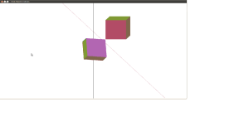

3 . Scaling
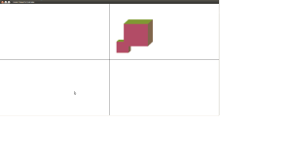

4 . Reflection

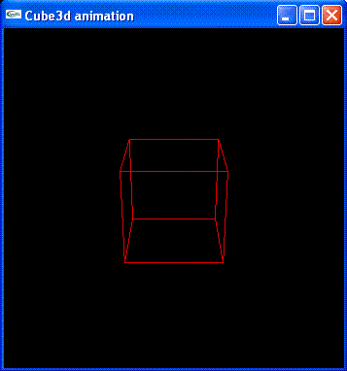

- OpenGL:-
(Open Graphics Library) is a specification defining a cross-language cross-platform API for writing applications that produce 3D computer graphics (and 2D computer graphics as well). The interface consists of over 250 different function calls which can be used to draw complex three-dimensional scenes from simple primitives. It is very popular in the video games industry where it competes with Direct3D on Microsoft Windows platforms. OpenGL is widely used in CAD, virtual reality, scientific visualization, information visualization, and video game development.
In order to start with a blank canvas:
glClear( GL_COLOR_BUFFER_BIT );
We now set the modelview matrix, which controls the position of the camera relative to the primitives we render. We move it backwards 3 units along the Z axis, which leaves it pointing towards the origin:
glMatrixMode( GL_MODELVIEW ); /* Subsequent matrix commands will affect the modelview matrix */
glLoadIdentity(); /* Initialise the modelview to identity */
glTranslatef( 0, 0, -3 ); /* Translate the modelview 3 units along the Z axis */
The projection matrix governs the perspective effect applied to primitives, and is controlled in a similar way to the modelview matrix:
glMatrixMode( GL_PROJECTION ); /* Subsequent matrix commands will affect the projection matrix */
glLoadIdentity(); /* Initialise the projection matrix to identity */
glFrustum( -1, 1, -1, 1, 1, 1000 ); /* Apply a perspective-projection matrix */
Finally, we issue a polygon - a green square oriented in the XY plane:
glBegin( GL_POLYGON ); /* Begin issuing a polygon */
glColor3f( 0, 1, 0 ); /* Set the current color to green */
glVertex3f( -1, -1, 0 ); /* Issue a vertex */
glVertex3f( -1, 1, 0 ); /* Issue a vertex */
glVertex3f( 1, 1, 0 ); /* Issue a vertex */
glVertex3f( 1, -1, 0 ); /* Issue a vertex */
glEnd(); /* Finish issuing the polygon */

- Direct3D:-
Direct3D is part of Microsoft's DirectX application programming interface (API). Direct3D is available for Microsoft Windows operating systems (Windows 95 and above), and for other platforms through the open source software Wine. It is the base for the graphics API on the Xbox and Xbox 360 console systems. Direct3D is used to render three dimensional graphics in applications where performance is important, such as games. Direct3D also allows applications to run fullscreen instead of embedded in a window, though they can still run in a window if programmed for that feature.
Direct3D uses hardware acceleration if it is available on the graphics card, allowing for hardware acceleration of the entire 3D rendering pipeline or even only partial acceleration. Direct3D exposes the advanced graphics capabilities of 3D graphics hardware, including z-buffering, spatial anti-aliasing, alpha blending, mipmapping, atmospheric effects, and perspective-correct texture mapping. Integration with other DirectX technologies enables Direct3D to deliver such features as video mapping, hardware 3D rendering in 2D overlay planes, and even sprites, providing the use of 2D and 3D graphics in interactive media ties.
Direct3D is a 3D API. That is, it contains many commands for 3D rendering; however, since version 8, Direct3D has superseded the old DirectDraw framework and also taken responsibility for the rendering of 2D graphics.[1] Microsoft strives to continually update Direct3D to support the latest technology available on 3D graphics cards. Direct3D offers full vertex software emulation but no pixel software emulation for features not available in hardware. For example, if software programmed using Direct3D requires pixel shaders and the video card on the user's computer does not support that feature, Direct3D will not emulate it, although it will compute and render the polygons and textures of the 3D models, albeit at a usually degraded quality and performance compared to the hardware equivalent.

- Maya software:-
Maya animation software offers a comprehensive creative feature set for 3D computer animation, modelling, simulation, rendering and compositing on a highly extensible production platform. Maya now has next-generation display technology, accelerated modelling workflows and new tools for handling complex data. Autodesk Maya, commonly shortened to Maya, is 3D computer graphics software that runs on Windows, Mac OS and Linux, originally developed by Alias Systems Corporation (formerly Alias|Wavefront) and currently owned and developed by Autodesk, Inc. It is used to create interactive 3D applications, including video games, animated film, TV series, or visual effects.
Maya is an application used to generate 3D assets for use in film, television, game development and architecture. The software was initially released for the IRIX operating system. However, this support was discontinued in August 2006 after the release of version 6.5. Maya was available in both "Complete" and "Unlimited" editions until August 2008, when it was turned into a single suite. Users define a virtual workspace (scene) to implement and edit media of a particular project. Scenes can be saved in a variety of formats, the default being .mb (Maya Binary). Maya exposes a node graph architecture. Scene elements are node-based, each node having its own attributes and customization. As a result, the visual representation of a scene is based entirely on a network of interconnecting nodes, depending on each other's information. For the convenience of viewing these networks, there is a dependency and a directed acyclic graph. Users who are students, teachers (or veterans or unemployed in USA markets) can download a full educational version from the Autodesk Education community. The versions available at the community are only licensed for non commercial use (once activated with the product license) and some products create watermarks on output renders.

- Blender Software:-
Blender is a free and open-source 3D computer graphics software product used for creating animated films, visual effects, art, 3D printed models, interactive 3D applications and video games. Blender's features include 3D modeling, UV unwrapping, texturing, rigging and skinning, fluid and smoke simulation, particle simulation, soft body simulation, sculpting, animating, match moving, camera tracking, rendering, video editing and compositing. It also features a built-in game engine. This software contains features that are characteristic of high-end 3D software. Among its capabilities are:
- Support for a variety of geometric primitives, including polygon meshes, fast subdivision surface modeling, Bezier curves, NURBS surfaces, metaballs, multi-res digital sculpting (including dynamic topology, maps baking, remeshing, resymetrize, decimation..), outline font, and a new n-gon modeling system called B-mesh.
- Internal render engine with scanline ray tracing, indirect lighting, and ambient occlusion that can export in a wide variety of formats.
- A pathtracer render engine called Cycles, which can take advantage of the GPU for rendering. Cycles supports the Open Shading Language since blender 2.65.
- Integration with a number of external render engines through plugins.
- Keyframed animation tools including inverse kinematics, armature (skeletal), hook, curve and lattice-based deformations, shape keys (morphing), non-linear animation, constraints, and vertex weighting.
- Simulation tools for Soft body dynamics including mesh collision detection, LBM fluid dynamics, smoke simulation, Bullet rigid body dynamics, ocean generator with waves.
- A particle system that includes support for particle-based hair.
- Modifiers to apply non-destructive effects.
- Python scripting for tool creation and prototyping, game logic, importing and/or exporting from other formats, task automation and custom tools.
- A fully integrated node-based compositor within the rendering pipeline accelerated with OpenCL.
- Screenshots for adding a sphere to the frame:-
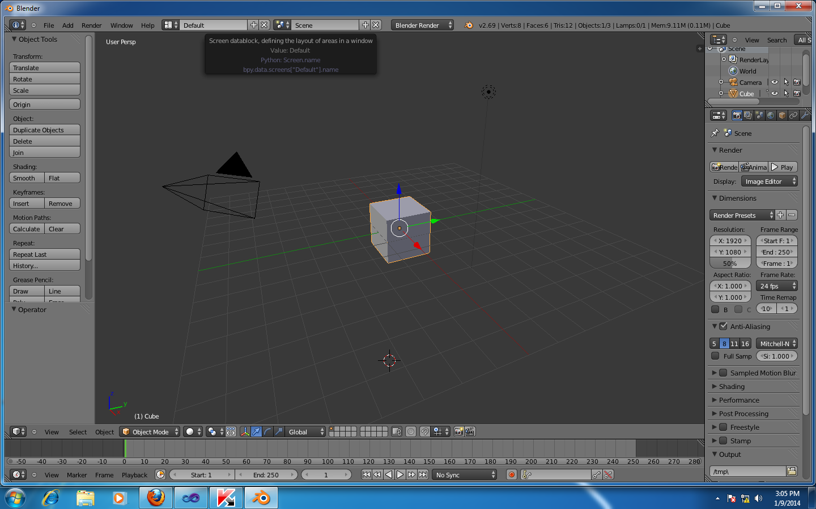

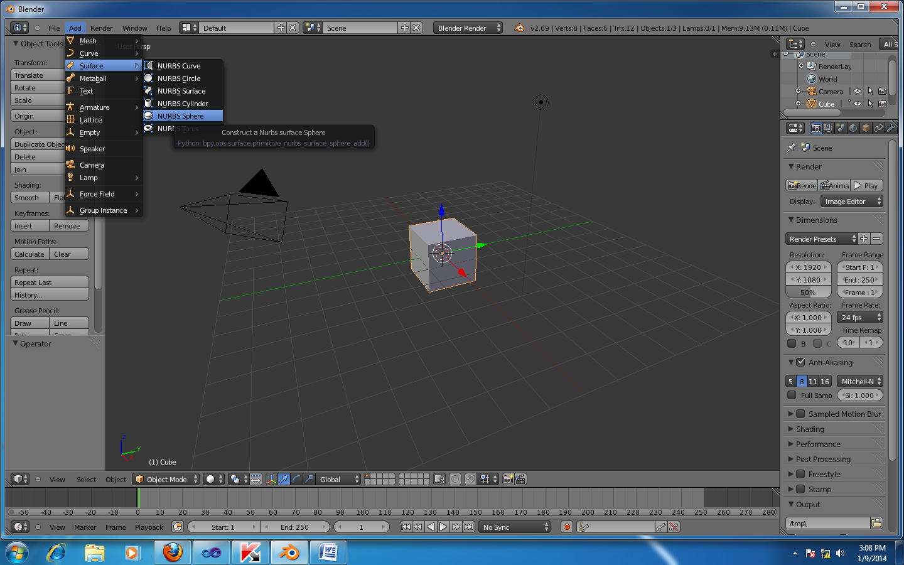

- Review Questions
- What is animation?
- Explain different types of animation?
- Explain importance and applications of animation?
- Extra assignment list
Write a C/C++ program for car animation by using Direct3D/Maya software/OpenGL?

- Conclusion :
After successfully completing this assignment, student should be able to understand and create animation by using OpenGL.

